**PROGRAM 8: STUDENT ENROLLMENT DATABASE**

Consider the following database of student enrollment in courses and books adopted for each course.

**STUDENT** (regno: String, name: String, major: String, bdate: date)

**COURSE** (course #: int, cname: String, dept: String)

**ENROLL** (regno: String, cname: String, sem: int, marks: int)

**BOOK_ADOPTION** (course #: int, sem: int, book-ISBN: int)

**TEXT**(book-ISBN:int, book-title:String, publisher:String, author:String)

i) Create the above tables by properly specifying the primary keys and the foreign keys.

ii) Enter at least five tuples for each relation.

iii) Demonstrate how you add a new text book to the database and make this book be adopted by some

department.

iv) Produce a list of text books (include Course #, Book-ISBN, Book-title) in the alphabetical order for

courses offered by the ‘CS’ department that use more than two books.

v) List any department that has all its adopted books published by a specific publisher.

create database Stud_Enrollment;

use Stud_Enrollment;

CREATE TABLE student(

regno VARCHAR(30),

name VARCHAR(50),

major VARCHAR(30),

bdate DATE,

PRIMARY KEY (regno));

desc student;

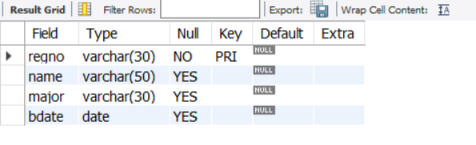

CREATE TABLE course(

courseno INT,

cname VARCHAR(20),

dept VARCHAR(20),

PRIMARY KEY (courseno));

desc course;

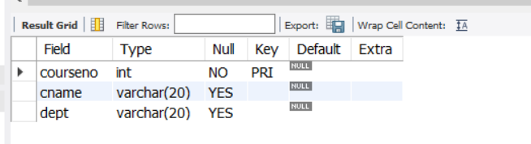

CREATE TABLE enroll(

regno VARCHAR(15),

courseno INT,

sem INT(3),

marks INT(4),

PRIMARY KEY (regno,courseno),

FOREIGN KEY (regno) REFERENCES student (regno),

FOREIGN KEY (courseno) REFERENCES course (courseno));

desc enroll;

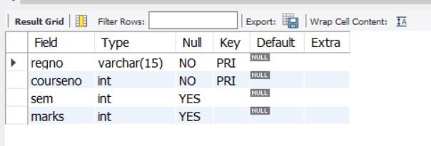

CREATE TABLE text(

book_isbn INT(5),

book_title VARCHAR(20),

publisher VARCHAR(20),

author VARCHAR(20),

PRIMARY KEY (book_isbn));

desc text;

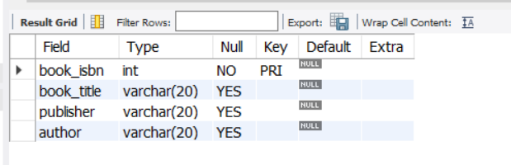

CREATE TABLE book_adoption(

courseno INT,

sem INT(3),

book_isbn INT(5),

PRIMARY KEY (courseno,book_isbn),

FOREIGN KEY (courseno) REFERENCES course (courseno) on update cascade,

FOREIGN KEY (book_isbn) REFERENCES text(book_isbn)on update cascade

);

desc book_adoption;

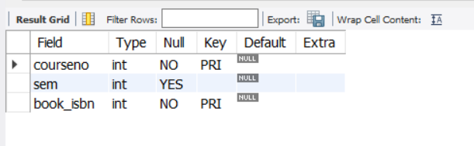

INSERT INTO student (regno,name,major,bdate) VALUES

('1BM19CS404','Md','sr','19930924'),

('1BM19CS401','Arbaz','sr','19931127'),

('1BM19CS400','Abhishek','sr','19930413'),

('1BM19CS402','Chirag','jr','19940824');

select * from student;

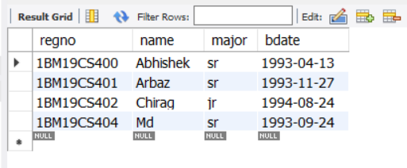

INSERT INTO course VALUES (111,'OS','CSE'),

(112,'TFCS','CSE'),

(113,'ADA','ISE'),

(114,'DBMS','CSE'),

(115,'C','ECE');

select * from course;

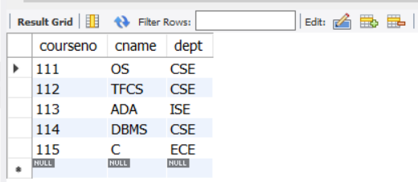

INSERT INTO text (book_isbn,book_title,publisher,author)VALUES

(10,'DATABASE SYSTEMS','PEARSON','SCHIELD'),

(900,'OPERATING SYS','PEARSON','LELAND'),

(901,'CIRCUITS','HALL INDIA','BOB'),

(902,'SYSTEM SOFTWARE','PETERSON','JACOB'),

(903,'SCHEDULING','PEARSON','PATIL'),

(904,'DATABASE SYSTEMS','PEARSON','JACOB'),

(905,'DATABASE MANAGER','PEARSON','BOB'),

(906,'SIGNALS','HALL INDIA','SUMIT');

select * from text;

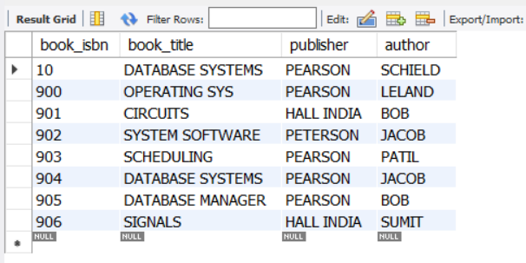

INSERT INTO enroll (regno,courseno,sem,marks) VALUES

('1BM19CS404',114,5,100),

('1BM19CS401',113,5,100),

('1BM19CS400',111,5,100),

('1BM19CS402',112,3,100);

select * from enroll;

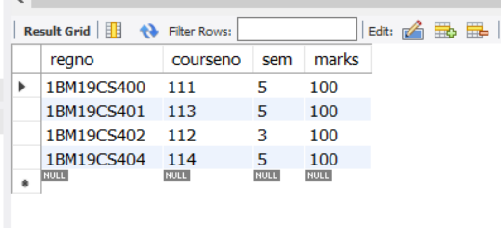

INSERT INTO book_adoption (courseno,sem,book_isbn) VALUES

(111,5,900),

(111,5,903),

(111,5,904),

(112,3,901),

(113,3,10),

(114,5,905),

(113,5,902),

(115,3,906);

select * from book_adoption;

commit;

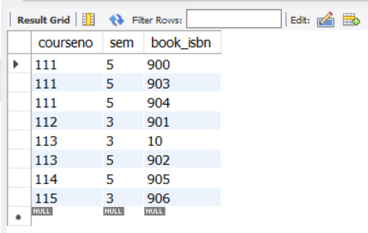

/*QUERIES:

01. Demonstrate how you add a new text book to the database

and make this book be adopted by some department */

INSERT INTO text (book_isbn, book_title, publisher,author) VALUES (23,'ADA','PEARSON','SCHIELD');

SELECT * FROM TEXT;

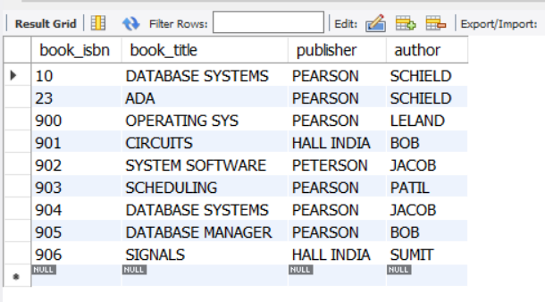

INSERT INTO book_adoption (courseno,sem,book_isbn) VALUES (111,5,23);

SELECT * FROM BOOK_ADOPTION;

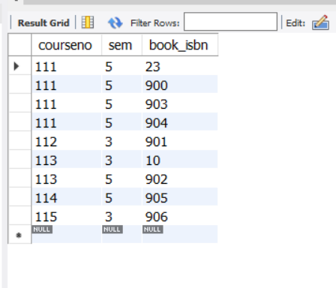

/*02. Produce a list of text books [include course #, Book ISBN, Book title] in the alphabetical order for courses offered by the “CS “ department that use more than two books. STUDENT ENROLLMENT DATABASE*/

SELECT c.courseno,t.book_isbn,t.book_title

FROM course c,book_adoption ba,text t

WHERE c.courseno=ba.courseno

AND ba.book_isbn=t.book_isbn

AND c.dept='CSE'

AND 2<( SELECT COUNT(book_isbn)

FROM book_adoption b

WHERE c.courseno=b.courseno)

ORDER BY t.book_title;

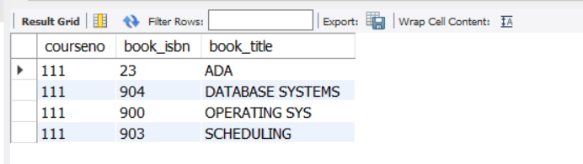

/*03. List any department that has all its adopted books published by a specific publisher. */

SELECT DISTINCT c.dept FROM course c

WHERE c.dept IN ( SELECT c.dept FROM course

c,book_adoption b,text t WHERE c.courseno=b.courseno

AND t.book_isbn=b.book_isbn

AND t.publisher='PEARSON') AND c.dept

NOT IN (SELECT c.dept FROM course c,book_adoption b,text t

WHERE c.courseno=b.courseno

AND t.book_isbn=b.book_isbn AND t.publisher ='PEARSON');

